
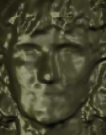


Database
3D sensor
3D Image
Shape
Texture
Facial Features Extraction
Registration of Shape with Texture
Attributed Relational Graph
(Shape and Texture)
Matching Scenarios:
2D – 2D
3D – 3D
Multimodal (2D + 3D)

Match

